Task 3: API Integration Project – Global Weather App
Submitted By
Ganeshji Sahu

Project Overview
The Global Weather App is a web application developed using HTML, CSS, and JavaScript. The application fetches real-time weather information using the OpenWeatherMap API and displays weather details for cities around the world.
The project demonstrates the use of REST APIs, Fetch API, DOM manipulation, and responsive web design. Users can search for any city and instantly view its current weather conditions.

Objectives
- To understand API integration in web applications.
- To fetch and display real-time data using JavaScript.
- To implement asynchronous programming using Fetch API.
- To create a responsive and user-friendly interface.
- To handle loading and error states effectively.

Technologies Used
- HTML5
- CSS3
- JavaScript (ES6)
- OpenWeatherMap API
- Netlify (Deployment)
- GitHub (Version Control)

Features
- Search weather by city name
- Real-time weather information
- Temperature display
- Weather condition display
- Humidity information
- Wind speed information
- Error handling for invalid city names
- Responsive design for desktop and mobile devices
- API integration using Fetch API

API Used
OpenWeatherMap API
The OpenWeatherMap API was used to retrieve real-time weather data for cities worldwide.
API Website:
https://openweathermap.org/api

Project Structure
Global-Weather-Application/
├── index.html
├── style.css
├── script.js
├── README.md
└── Screenshots/

Hosted Project Link
https://global-weather-in.netlify.app/
GitHub Repository Link
https://github.com/Ganeshsahu09/Global-Weather-Application
Screenshots
Home Screen
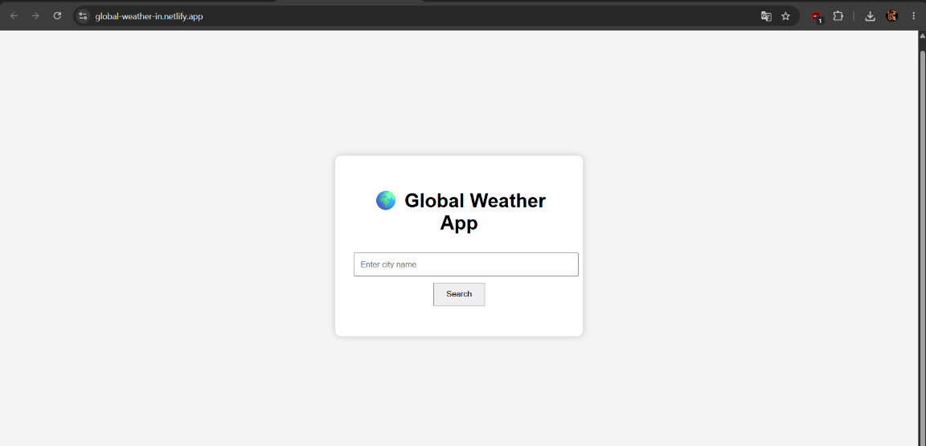
Successful Weather Search
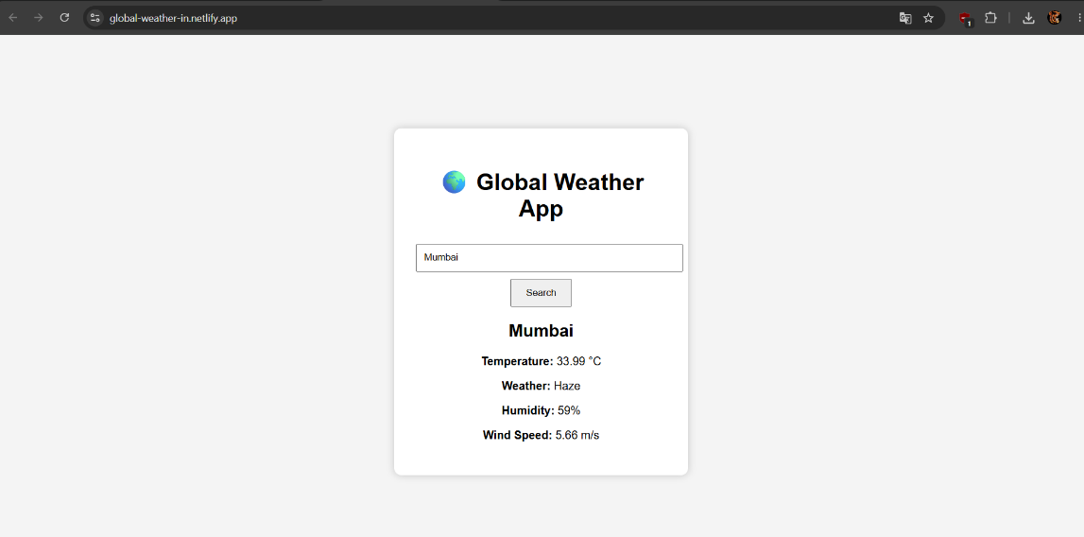
Another Country Search
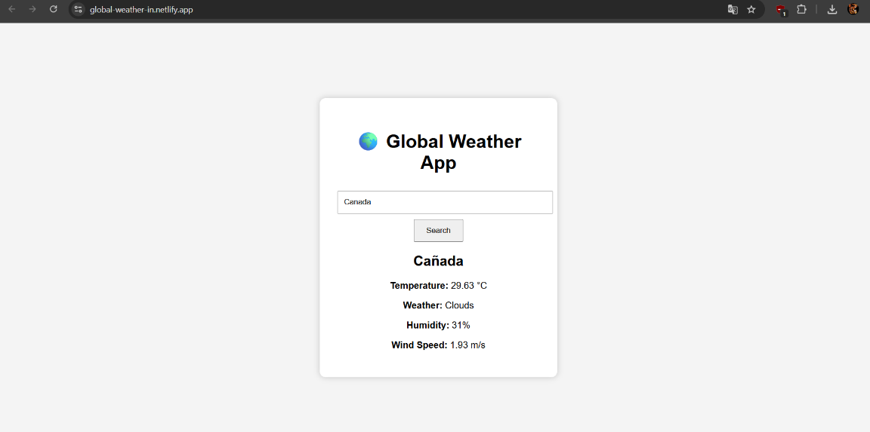
Error State
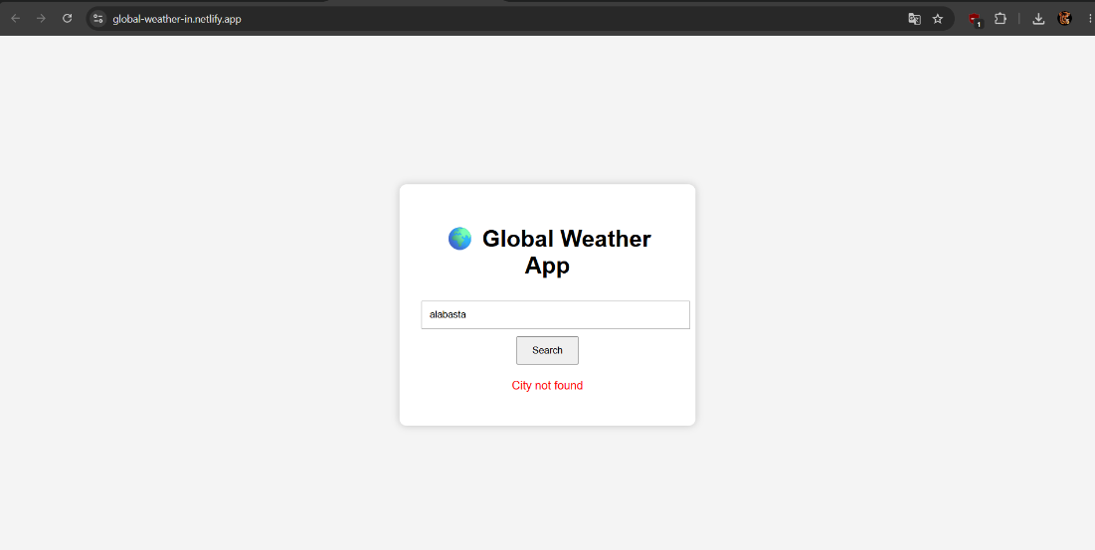
Mobile Responsive View
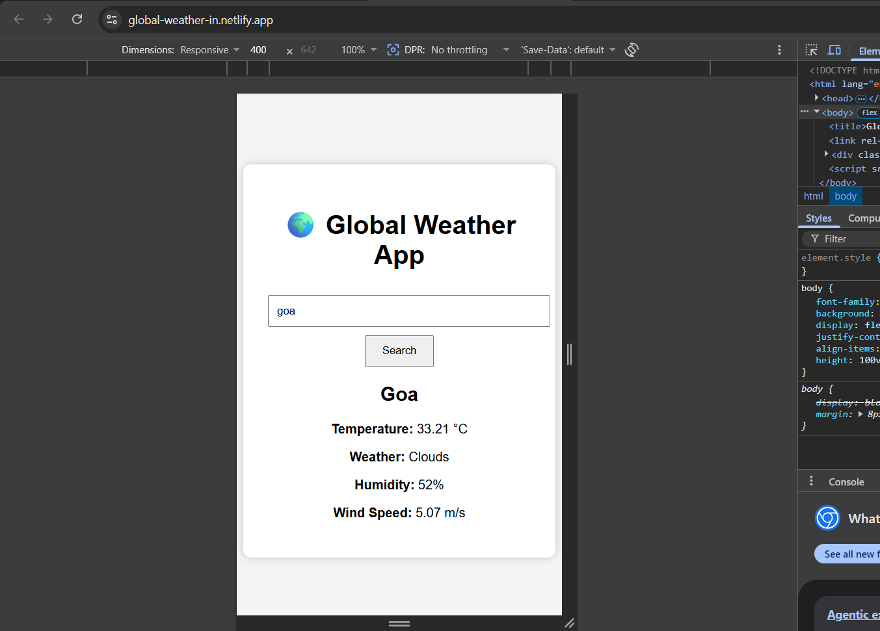
Sample Code Snippets
Fetch API Request
const response = await fetch(
`https://api.openweathermap.org/data/2.5/weather?q=${city}&appid=${apiKey}&units=metric`
);
This code sends a request to the OpenWeatherMap API and retrieves weather information for the entered city.
Error Handling
if (!response.ok) {
throw new Error("City not found");
}
This ensures that invalid city names are handled properly and an error message is displayed to the user.

Learning Outcomes
Through this project, I gained practical experience in:
- Working with REST APIs
- Using Fetch API
- Handling asynchronous JavaScript operations
- Processing JSON data
- DOM manipulation
- Error handling
- Responsive web design
- Deploying web applications using Netlify

Conclusion
The Global Weather App successfully demonstrates API integration using JavaScript and the OpenWeatherMap API. The application allows users to search weather information for cities worldwide and displays real-time weather data in a responsive interface. This project helped strengthen my understanding of API integration, asynchronous programming, and front-end web development concepts.

